EXCEL ASSIGNMENT

Q1. What is the difference between 'Paste' and 'Paste Special' in Excel? Briefly explain with examples.
Answer:
Paste:
Paste is used to insert the copied data exactly the same as the original. It copies everything such as values, formulas, and formatting. It is the normal and most commonly used option.
Example:
If we copy a cell that has the formula =A1+B1 and paste it normally, the formula and formatting will also be pasted in the new cell.
Paste Special:
Paste Special is used when we want to paste only a specific part of the copied data. It gives options like Values, Formulas, and Formats.
Example:
If a cell contains the formula =A1+B1 and the result is 50, using Paste Special → Values will paste only 50, not the formula.
Conclusion:
Paste copies the complete data, while Paste Special allows us to choose what we want to paste. It helps in better data management in Excel.

Q2.: Describe the functions and usefulness of 'Freeze Panes' and 'Split Panes' in Excel.
Answer:
Freeze Panes:
Freeze Panes is used to lock specific rows or columns so that they remain visible while scrolling the worksheet. This is very helpful when working with large data where headings are important.
Example:
If we have a table with many rows and the column headings are in the first row, we can use Freeze Panes to keep the first row visible while scrolling down. This helps understand the data without losing track of the headings.
Usefulness:
- Keeps important rows or columns visible
- Makes data easier to read and understand
- Useful for large datasets
Split Panes:
Split Panes is used to divide the worksheet into different sections. Each section can be scrolled separately. It does not lock rows or columns but helps in viewing different parts of the same sheet at the same time.
Example:
We can split the screen into two or four parts to compare data from different sections of the worksheet.
Usefulness:
- Helps in comparing different parts of data
- Allows multiple views of the same worksheet
- Makes working with large data more convenient
Conclusion:
Freeze Panes is used to keep important rows or columns fixed, while Split Panes is used to divide the screen for better viewing. Both features help in working efficiently with large data in Excel.

Q3. : Explain the difference between inserting a new row and inserting a new column in Excel. Can you insert multiple rows or columns at once?

Answer:
Inserting a New Row:
When we insert a new row, a blank row is added horizontally in the worksheet. The existing rows shift downward.
Example:
If we insert a row at row 3, the old row 3 will move to row 4, and a new empty row will be created at row 3.
Inserting a New Column:
When we insert a new column, a blank column is added vertically. The existing columns shift to the right.
Example:
If we insert a column at column B, the old column B will move to column C, and a new empty column will be created at column B.

Yes, we can insert multiple rows or columns at the same time.
How:
- Select the number of rows or columns you want to insert
- Right-click and choose Insert
Example:
If you select 3 rows and click Insert, Excel will add 3 new rows at once. The same method works for columns.

Conclusion:
Inserting a row adds space horizontally, while inserting a column adds space vertically. Excel also allows inserting multiple rows or columns together, which saves time while working with large data.

Q.4 What are logical functions in Excel? Provide examples of at least two logical functions and their applications.
Answer:
Logical functions are used to make decisions based on certain conditions. They check whether a condition is true or false and return a result based on that.

1. IF Function
The IF function is used to check a condition and return one value if the condition is true and another value if it is false.
Example:
=IF(A1>50, "Pass", "Fail")
If the value in cell A1 is greater than 50, it will show Pass, otherwise it will show Fail.
Application:
- Used for result analysis (Pass/Fail)
- Used in grading systems
- Helps in decision making

2. AND Function
The AND function checks multiple conditions at the same time. It returns TRUE only if all conditions are true.
Example:
=AND(A1>50, B1>50)
It will return TRUE only if both A1 and B1 are greater than 50.
Application:
- Used when multiple conditions must be satisfied
- Helpful in checking eligibility criteria

Conclusion:
Logical functions in Excel help in making decisions and analyzing data easily. Functions like IF and AND are widely used to check conditions and get the desired results.

Q5. Discuss the purpose of 'XLOOKUP' and how it differs from the traditional 'VLOOKUP' function.

Answer:
XLOOKUP and VLOOKUP are used to search for data in a table, but XLOOKUP is a more advanced and flexible function.

Purpose of XLOOKUP:
XLOOKUP is used to find a value in a range and return a matching result from another range. It can search vertically or horizontally and is easier to use.
Example:
=XLOOKUP (A2, A1:A10, B1:B10)
This formula looks for the value of A2 in the range A1:A10 and returns the matching value from B1:B10.
Usefulness:
- Can search in any direction
- Works for both vertical and horizontal data
- Handles errors easily (can show custom message if not found)

VLOOKUP Function:
VLOOKUP is an older function used to search for a value in the first column of a table and return a value from another column.
Example:
=VLOOKUP (A2, A1:B10, 2, FALSE)
This looks for A2 in the first column and returns the value from the second column.

Difference between XLOOKUP and VLOOKUP:
XLOOKUP | VLOOKUP
Can search in any direction | Searches only from left to right
Easy to use (no column number needed) | Requires column number
Can return custom message if not found | Shows error if not found
Works for both vertical and horizontal lookup | Works only for vertical lookup
More advanced and flexible | Older and limited

Conclusion:
XLOOKUP is a modern and more powerful function compared to VLOOKUP. It is easier to use and provides more flexibility while working with data in Excel.

Q6. Create a worksheet titled 'Employee Data' with columns: Name, Age, Department. Add 5 rows of data.
Answer:

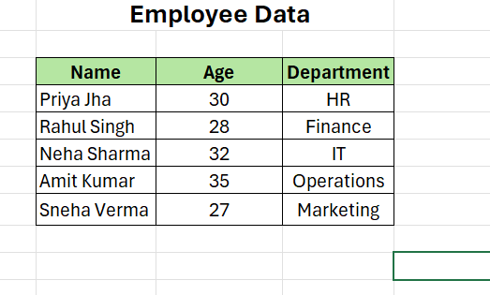

Question 7: Demonstrate how to insert and delete multiple rows and columns in Excel.
Answer:
Before insert Row and column

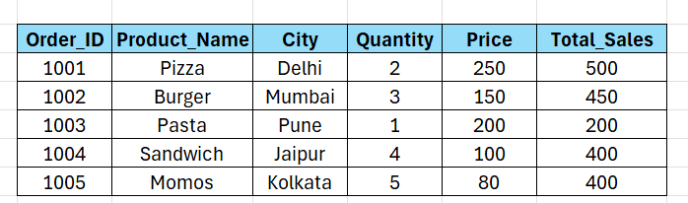
After insert Row:

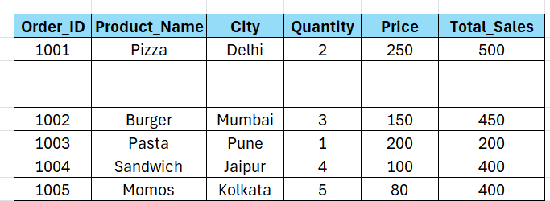

After insert column:
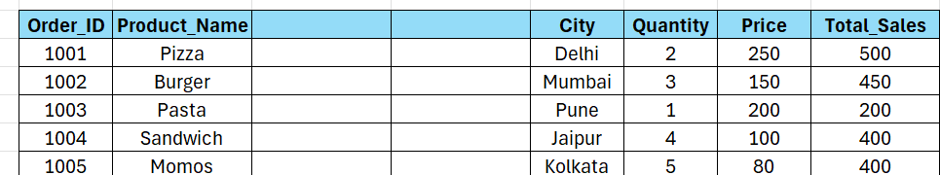

Q8. Use Excel's 'Find and Replace' feature to update department names in a sample table.
Answer:

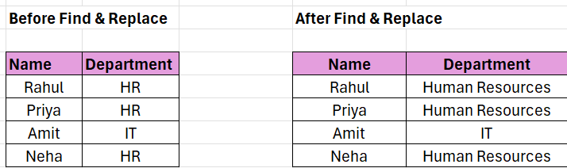

Question 9: Create a small numerical dataset and apply the following functions:
● AVERAGE ● MAX ● MIN
Answer:
Average Formula:
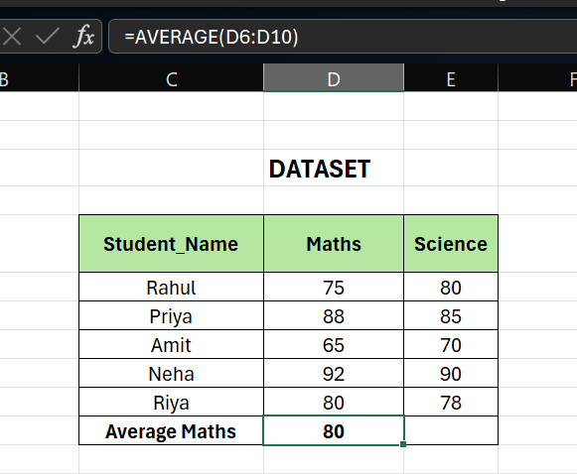
MAX Formula:
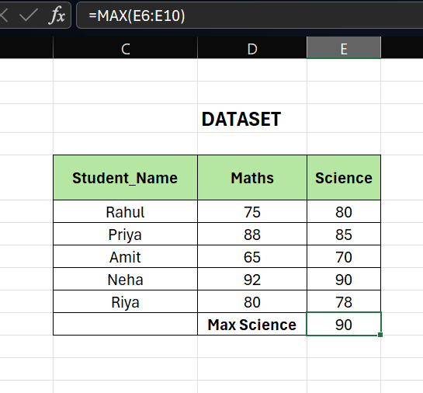
MIN Formula:
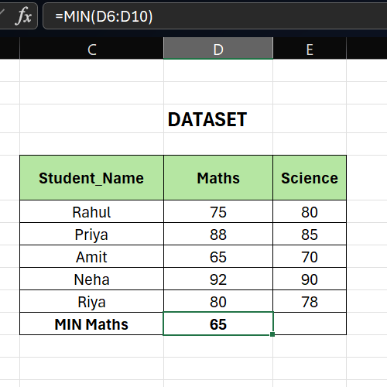

Question 10: You're working with a dataset that contains missing values. As a Data Scientist, explain how you'd detect and handle missing data using Excel. Mention tools like:
● Go To Special
● ISBLANK
● COUNTBLANK

Answer:
Below is the sample Dataset
(Blank cells represent missing data)

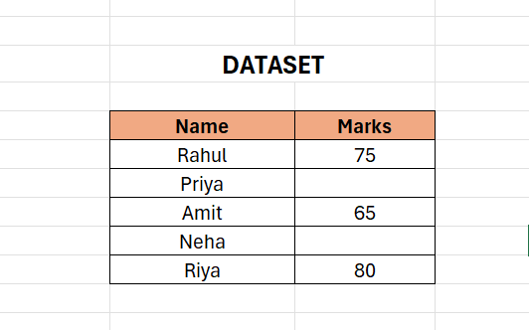

Detect Missing Data:
Go To Special (Quick Highlight Method)
- Select the dataset
- Press Ctrl + G → Click Special
- Select Blanks → Click OK
Excel will highlight all empty cells instantly.
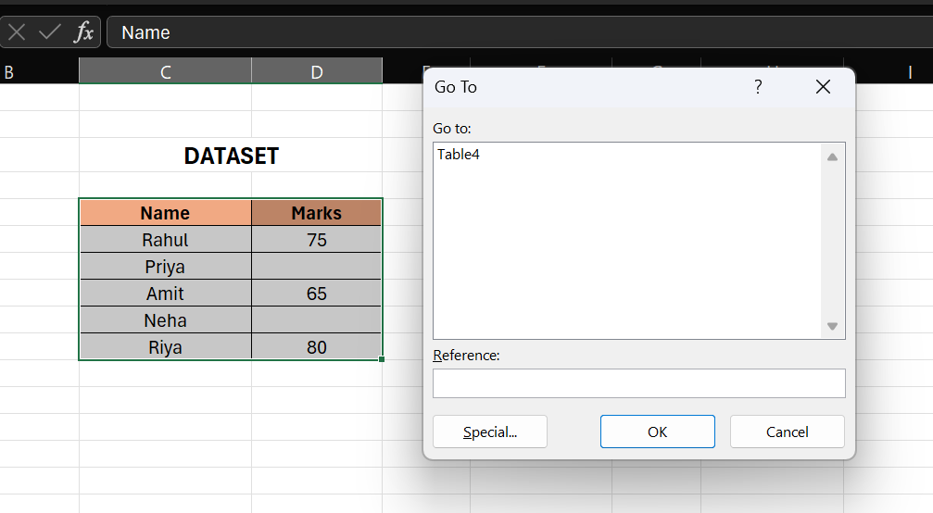
Click on Special and select blanks and ok
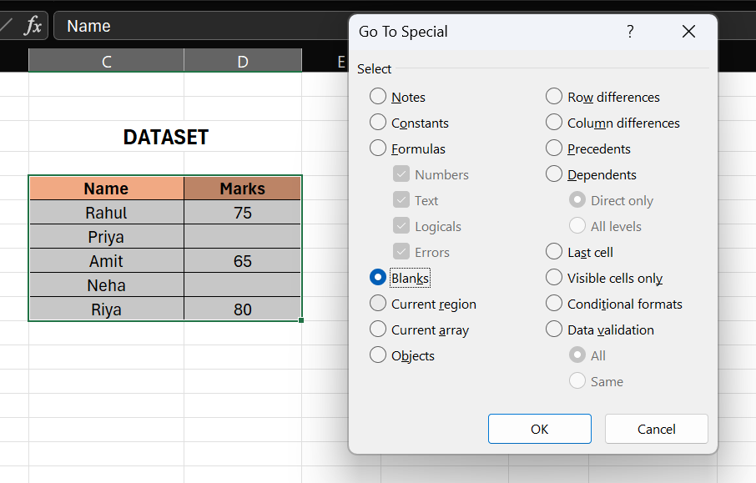

Excel will highlight all empty cells instantly:
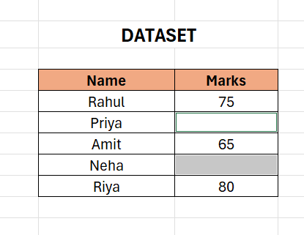

ISBLANK Function:

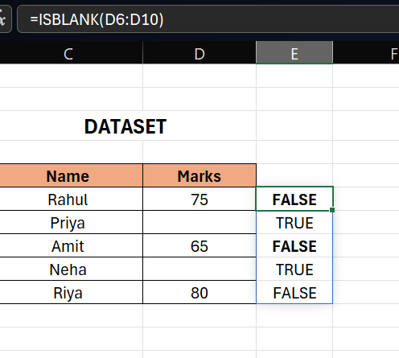

Result:
- TRUE → if cell is empty
- FALSE → if cell has data
It helps identify missing values row by row

COUNTBLANK Function:
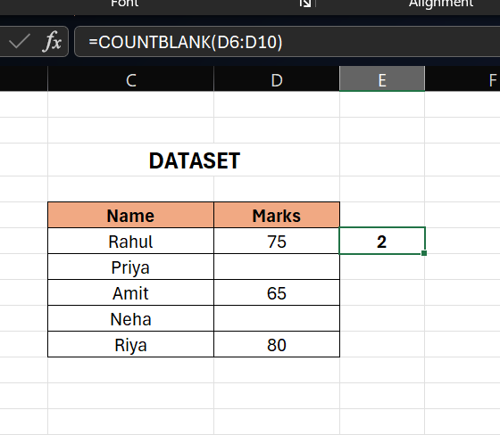

Result: 2 number of blank cells

How to Handle Missing Data
As a Data Scientist, we can:
- Fill with average value
→ =AVERAGE (B2:B6)
- Replace with 0 or text (like "Not Available")
- Delete rows (if data is not important)

